**PLANNING FOR YOUR STUDY IN THE WEEKS PRIOR TO THE HSC EXAMS**

**STEP 3: List your exams and how many days you had to study for them. See if you are happy for the spread or if you want to do change the allocation.**

|  |  |  |  |  |  |  |  |  |  |  |  |  |  |
| --- | --- | --- | --- | --- | --- | --- | --- | --- | --- | --- | --- | --- | --- |
| *Strongest Subjects* | *Days in exam block* | *Days in hols* | *Total* |  | *Middle Subjects* | *Days in exam block* | *Days in hols* | *Total* |  | *Weakest Subjects* | *Days in exam block* | *Days in hols* | *Total* |
|  |  |  |  |  |  |  |  |  |  |  |  |  |  |
|  |  |  |  |  |  |  |  |  |  |  |  |  |  |

**STEP 2: Plan the weeks before the exams start – the Sept/Oct holidays (cross out the days that you are still at school)**

|  |  |  |  |  |  |  |
| --- | --- | --- | --- | --- | --- | --- |
| M15 Sept: most students still at school this week | T16 | W17 | T18 | F19 | S20 | S21 |
| M22 some schools may not have classes this week | T23 | W24 | T25 | F26 | S27 | S28 |
| M29 HOLIDAYS | T30 | W1 October | T2 | F3 | S4 | S5 |
| M6 HOLIDAYS | T7 | W8 | T9 | F10 | S11 | S12 |

**STEP 1:** **Work backwards from your last exam.**

|  |  |  |  |  |  |  |
| --- | --- | --- | --- | --- | --- | --- |
| M13 October | T14 | W15 | T16  **ENGLISH EXAM** | F17  **ENGLISH EXAM** | S18 | S19 |
| M20 | T21 | W22 | T23 | F24 | S25 | S26 |
| M27 | T28 | W29 | T30 | F31 | S1 November | S2 |
| M3 | T4 | W5 | T6 | F7 | S8  **HSC IS FINISHED!** | S9 |

**DECISIONS TO MAKE ABOUT THE WEEKS BEFORE THE FIRST EXAM**

1. How many hours of study do you want to do per day when you aren’t having classes? _____
2. What will be your timeslots for each day, how will you structure your day? Some examples are listed below, but what will you do?

Some examples of how you might structure your day:

|  |  |  |  |  |  |
| --- | --- | --- | --- | --- | --- |
| 6 hours per day | 6 hours per day | 8 hours per day | 8 hours per day | 7 hours per day | Your starting point timeslots: |
| 9-12 subject 1  2-5 subject 2 | 10-12 subject 1  2-4 subject 2  6-8 choose 1 or 2 | 9-12 subject 1  2-5 subject 2  7-9 choose 1 or 2 | 9-11 subject 1  12-2 subject 2  4-6 subject 1  7-9 subject 2 | 9-10 review  11-2 subject 1  3-6 subject 2 |  |

*Note:*

* Start by 10am at the latest so your sleep patterns don’t get thrown out
* Great for memory if you spend an hour in the morning reviewing what you did the previous day
* Choose a minimum amount of time and if you do more that’s great. Many students aim for 6 hours and do more if they can.

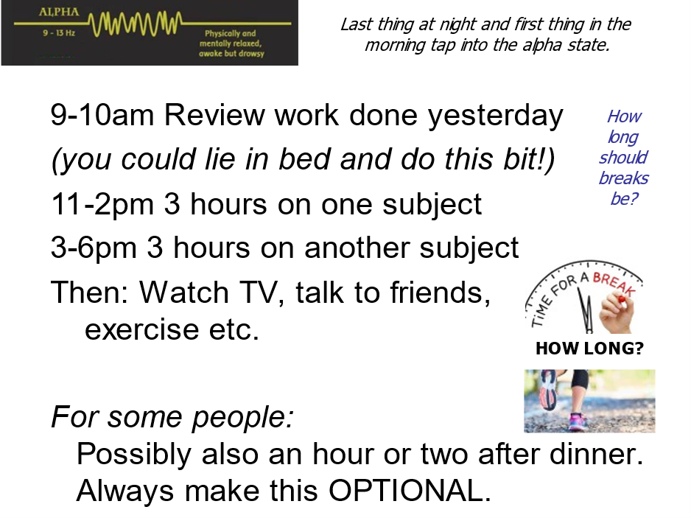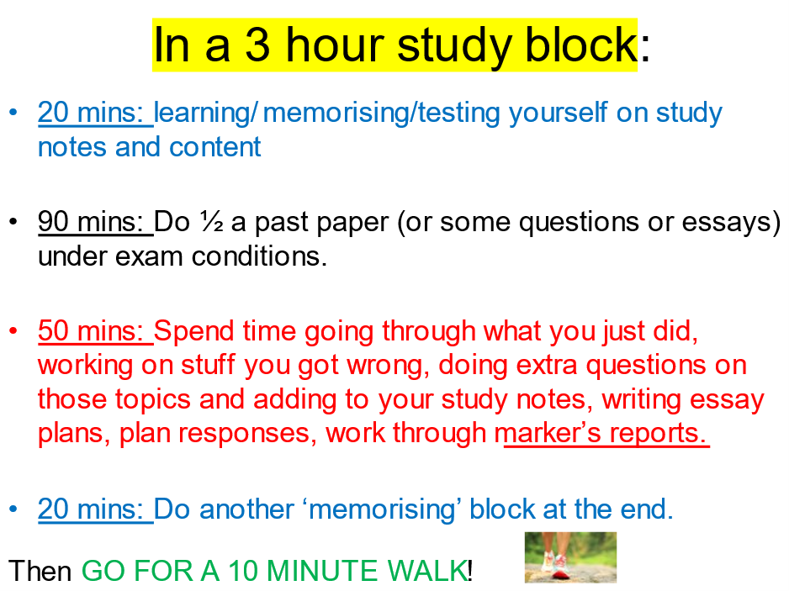

|  |  |
| --- | --- |
|  | **Your notes:** |

**SUBJECT AUDIT**

|  |  |  |  |  |  |  |  |  |
| --- | --- | --- | --- | --- | --- | --- | --- | --- |
| **SUBJECT:** |  |  |  |  |  |  |  |  |
| What do you want to get done for this subject by the end of term?  Feedback? Study notes?  Spot revision?  Chapter reviews?  Essays? |  |  |  |  |  |  |  |  |

|  |  |  |  |  |  |  |
| --- | --- | --- | --- | --- | --- | --- |
| PLANNING STUDY FOR THE REST OF THE TERM WHILE AT SCHOOL: During the week allocate 1 or 2 subjects to focus on each night and 2-3 per day on the weekend.  Cross out any days that you are on holidays. This section is just focusing on term time. | | | | | | |
| M11 August | T12 | W13 | T14 | F15 | S16 | S17 |
| M18 | T19 | W20 | T21 | F22 | S23 | S24 |
| M25 | T26 | W27 | T28 | F29 | S30 | S31 |
| M1 September | T2 | W3 | T4 | F5 | S6 | S7 |
| M8 | T9 | W10 | T11 | F12 | S13 | S14 |
| M15 | T16 | W17 | T18 | F19 | S20 | S21 |

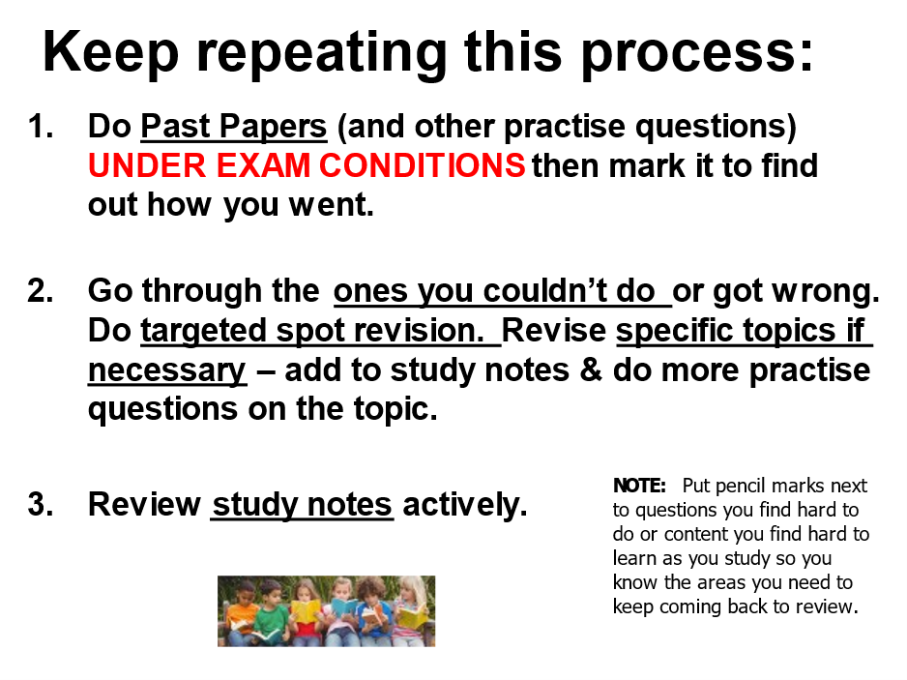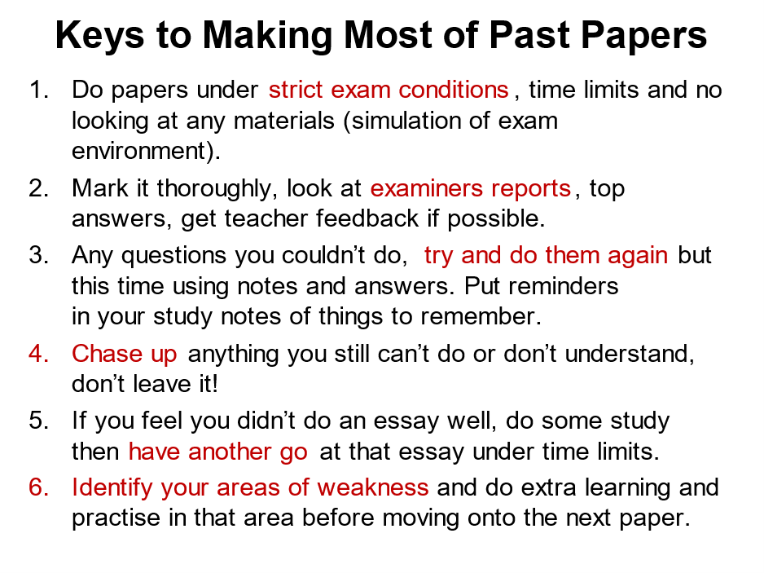

**At the end of the term, do a new subject audit. What do you want to get done in the holidays before the exams start?**

**SUBJECT AUDIT FOR THE HOLIDAYS**

|  |  |  |  |  |  |  |  |  |
| --- | --- | --- | --- | --- | --- | --- | --- | --- |
| **SUBJECT:** |  |  |  |  |  |  |  |  |
| What do you want to get done for this subject before the exams start  How many essays? Past papers? What other revision? Specific topic revision? |  |  |  |  |  |  |  |  |

**SLIDES:** <https://enhanced-learning.net/eles/slides.html> find Year 12 at the bottom of the page, password: **success**

**Extra resources:** [**www.studyskillshandbook.com.au**](http://www.studyskillshandbook.com.au) **if your school subscribes**